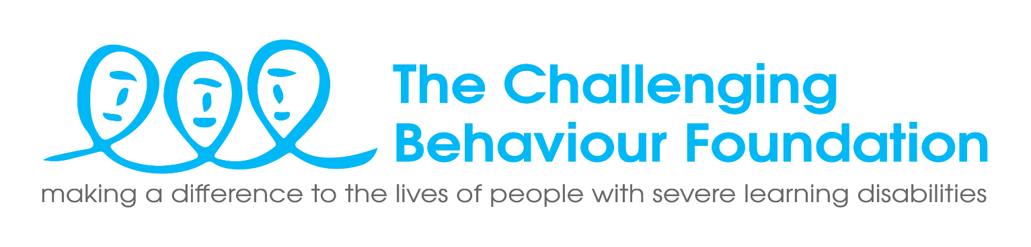
Person Specification - Communications Officer
Applicants will be expected to demonstrate the following through the recruitment process. Please detail your skills, experience and knowledge for all items marked with * in your CV or covering letter.

Experience and knowledge
 |  | Essential/ Desirable
1. | Knowledge of the key elements to plan and create effective communication campaigns and activities that engage audiences with the charity’s mission and purpose | Essential*
2. | Creative with excellent written communication skills and the ability to source, write and edit engaging, compelling and accessible content for a range of audiences (including families, supporters and professionals). | Essential*
3. | Knowledge and understanding of audiences for different media channels/social media platforms, with the ability to create, plan and deliver effective and engaging content and campaigns accordingly. | Essential*
4. | Ability to research, source and manage relevant assets (case studies, photos, videos) to help communicate our work effectively and consistently. | Essential*
5. | Experience of planning and delivering successful and impactful communications on behalf of an organisation across a range of channels | Desirable*
6. | Experience of content management systems (we use WordPress) | Desirable*
7. | Understanding of data management, data protection and legal requirements | Desirable*
8. | Experience of image and video editing (Adobe Creative Cloud, Canva and InDesign) | Desirable*

Skills / personal qualities

 | Able to learn quickly to achieve a good understanding and commitment to the core aims of The CBF including our vision, mission and objectives. | Essential
 | An understanding of, and commitment to, equality, diversity and human rights | Essential
 | Excellent organisational skills with great attention to detail and the ability to meet deadlines through prioritising and managing a busy and varied workload. | Essential*
 | Strong IT skills with sound knowledge of a range of digital tools. | Essential*
 | Comfortable working in a fast-paced and often changing environment, while remaining focussed and proactive. | Essential
 | A highly resourceful and problem-solving team-player with the ability to work collaboratively, internally and externally | Essential
 | A willingness to undertake appropriate training and development | Essential
 | Knowledge and understanding of learning disabilities and related issues | Desirable

