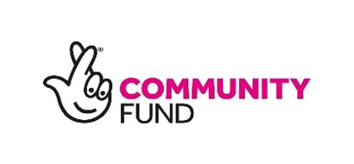 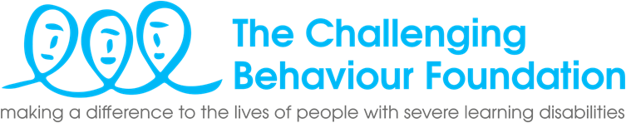

**Job Description – Forward Together Family Carer Project Worker (Manchester & Salford)**

**Title of post:** **Forward Together Family Carer Project Worker**

**Responsible to:** **Forward Together Project Lead**

**Hours:** 4 hours a week, worked flexibly

**Contract:** Fixed term contract (to end June 2027)

**Salary:** Real Living Wage - Currently £12.60 ph

**Location:** Home based (you must live in Manchester or Salford)

**BACKGROUND:**

The Challenging Behaviour Foundation (The CBF) worked in 3 regions in England to deliver a National Lottery Community Fund project “G*etting it* *Right*” from February 2019 to June 2023. Learning from and building on that project, new work has been funded. The Forward Together project, also funded through the National Lottery Community Fund will work with 3 regions to connect with local stakeholders, develop a regional Community of Practice, facilitate meetings, agree and implement actions and link to the established Challenging Behaviour National Strategy group (CB NSG).

**OBJECTIVE:**

To utilise your lived experience to support the delivery of the Forward Together Project plan (a new 3-year project funded by the National Lottery) to improve services and support for people with severe learning disabilities whose behaviour challenges, and their family carers in the North West. Your role will focus on identifying local contacts, groups and initiatives that can contribute to the new Community of Practice that will be set up in year 1. In years 2 and 3, working with the project lead, other CBF staff, local contacts and the 2 other regional Family Carer Project Workers, you will support the delivery of biannual meetings.

**RESPONSIBILITIES:**

Responsibilities will include working with colleagues and local stakeholders to set up the North West Community of Practice (NWCoP) and deliver the Forward Together project by:

1. Using your experience of local/ regional groups and networks to identify key individuals and groups to engage as part of this project
2. Agreeing with the project lead who to approach and setting up meetings online to share information and recruit NWCoP members
3. Providing regular email updates to project partners, stakeholders and local networks to ensure continued engagement and co-production of the NWCoP
4. Attending and contributing your lived experience to meetings and implementing follow up actions.
5. Facilitating meetings with family carers and stakeholders to gather views and experiences and suggestions for the CoP.
6. Recording actions and progress to feed into the project reporting processes
7. Making effective use of supervision, to progress actions and support your own wellbeing.
8. Following CBF’s policies and procedures including safeguarding and confidentiality.
9. Attendance at internal project meetings with CBF colleagues to input ideas and update on progress
10. Any other tasks as determined by the Line Manager.