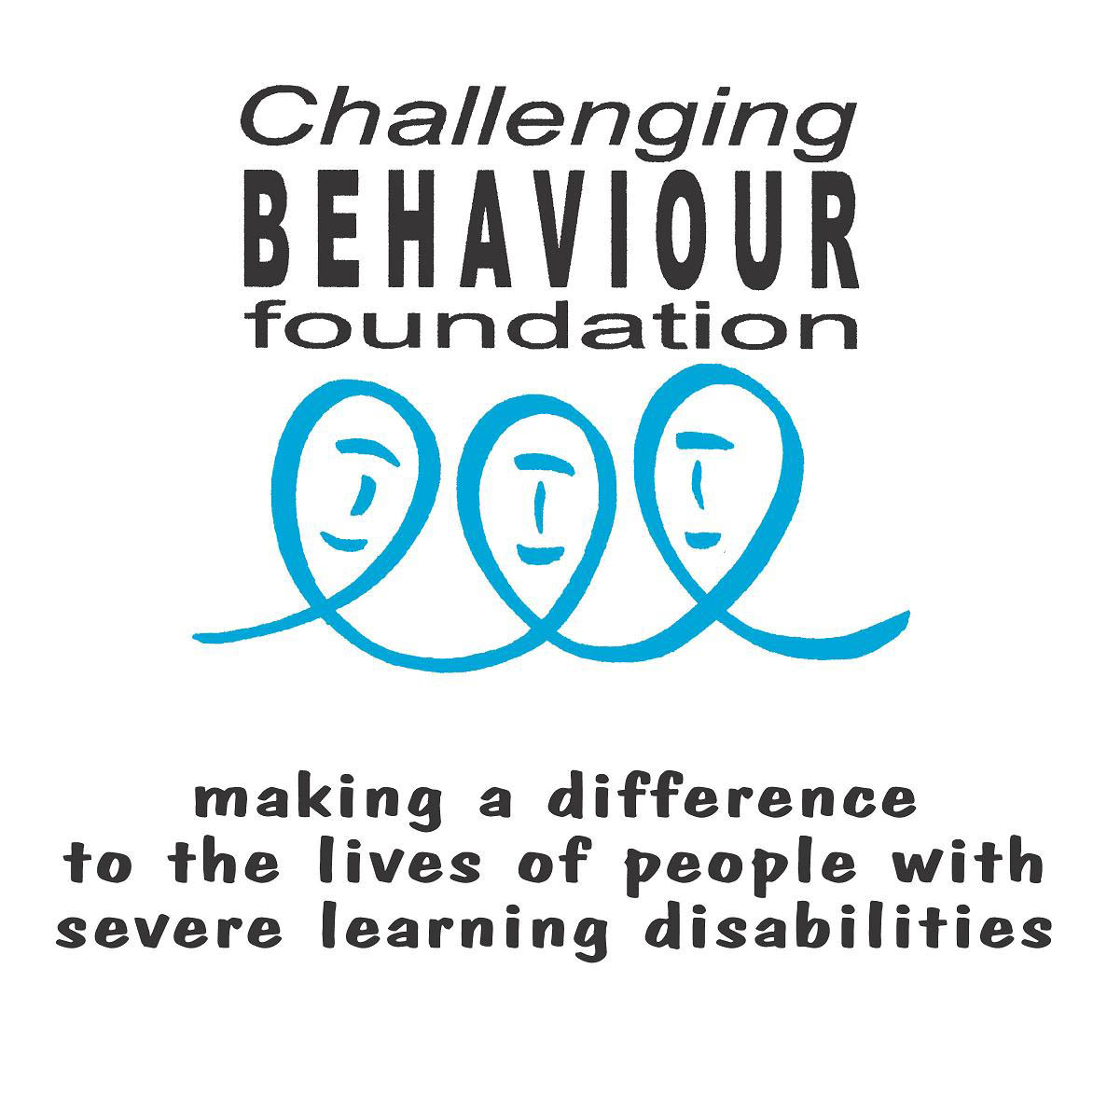

Challenging Behaviour Foundation Training Workshops

Expression of Interest

Contact Name

Organisation
Contact Telephone Number

Contact Email address

- Location where you would like the training to take place (e.g. Oxford)
- Can you provide a training venue
(See notes below)

Dates when you would like to receive the training (approx)
- Do you already have funding in place for the training?
- If training is for family carers, do you have funding for their travel expenses & replacement care costs (if applicable)?
Who is the training for? | Family Carers  Professionals  Both
Which workshops are you interested in? | Part 1 & 2 (understanding & supporting change)  Communication
Approximate numbers to attend training (maximum 35)
Any further comments

Please email completed form to training@thecbf.org.uk or post to: CBF, The Old Courthouse, New Road Avenue, Chatham, Kent ME4 6BE

Facilities and equipment for workshops

The following are items we ask the key contact person to provide for CBF training workshops. Please return the completed form to training@thecbf.org.uk Thank you.

Facilities and equipments | Able to provide
A room for training | Yes / No
Tables & Chairs | Yes / No
A screen & a projector (for PowerPoint presentations) | Yes / No
Flip chart & pens | Yes / No
Tea & Coffee | Yes / No
Lunch (if training scheduled over lunchtime e.g. 10.30am – 2.30pm) | Yes / No
We would be very grateful if you could inform us of any arrangements required for additional support below. Please note the following may not be included in the initial quote & may incur an additional charge.
Arrangements for additional support: | Do participants require:
Replacement care costs (e.g. for family carers) | Yes / No
Travel costs (e.g. for family carers) | Yes / No
Large print (handouts) | Yes / No
A translator  (If yes please specify language) | Yes / No
Other:

